Diminished Growth of Radish Seeds When Exposed to Mature Radish Bulb

By: SHS Maclean Team 5 (Cindy Lee, Addie Coyle, and Andrew Shepherd)

ABSTRACT:

Being aware of the chemicals in a plant, this experiment focuses on the growth of radish seedlings when it is affected by the chemicals from a full grown radish body, leaves, and roots. Radish seeds are planted vertically inside of ziplock bags. Three of the bags were considered the control groups, meaning that the radishes in those bags were using plain water. The additional bags were given radish parts and abstracts to test if the chemicals they release truly have an effect on radish growth. The control average came out slightly taller than the rest of the other averages at 17 centimeters. The roots and leaves abstracts were distinctly close in average heights --15.5 for roots and 15.8 for leaves-- and the bulb took a deep detour and grew the least tallest at 8.1 centimeters. As predicted, the bulb came out least effective in the growth of other radishes sharing the same environment.

INTRODUCTION:
Many plants have the special ability to release chemicals. Why do they need to release chemicals? According to Journey North, a partnership group of citizen scientists in North America, plants may use Allelopathy, which is “a chemical process that a plant uses to keep other plants from growing too close to it.” There are several types of allelopathy and several reasons why plants use it. Plants may also use volatilization, leaching, and exudation chemical releasing techniques. “Volatilization is the process whereby a dissolved sample is vaporized. This can greatly affect surrounding plants and the results may be deadly. Leaching is when some plants release protective chemicals into their leaves when the leaves detach from the body of the plant. Exudation is when plants release their protective chemicals through their roots. With this knowledge, a science experiment was designed; focusing on how the chemicals from the leaves, roots, and body of a full grown radish affect growing radish sprouts.

HYPOTHESIS:
Because most of the bitterness is in the bulb, it may contain more chemicals than the roots and leaves; therefore, the radish body may either be most effective in enhancing the growth or least effective and deterring the growth of other radishes sharing the same environment.

MATERIALS:
- Radish Seeds (x36)
- Ziplock Bags (x12)
- Rulers (x6)
- Box (x1) 10”x18”x10”
- Deionized Water (100mL Per) plus
- Mature Radish (x1) in Full, with roots and leaves as intact as possible
- Cutting Implement (x1, scissors or knife)
- Graphing Paper (x12) 0.5mm squares
- Beakers (x2)
- Hot Plates(X2) Or other similar heating elements

METHOD:
First off, it will be necessary to have the concentrates available so as to actually add them to the bags for the experiment.
- Take the full radish, root, leaf, and separate them into the root, bulb, and leaf sections
- Take the two beakers and add 150mL of deionized water
- In one beaker add the root, which should be as clean of dirt as possible
- In the other beaker add the leaves, also as clean as possible
- Set temperature to medium and allow to sit for 30 minutes
- While waiting, begin cutting mature radish bulb into roughly the same sized shapes, making for 27 chunks
- Turn off heat and wait for heat to dissipate
- Cover with plastic wrap and let sit until room temperature (Overnight works as well)

This step involves making for the mounting section for the seeds. The seeds are to grow out of the water so as to not drown them. The necessary steps are as follows:
- Cut graph paper to fit the ziploc (or equivalent) bags
- Create small holes to fit seeds in
- Wet holes with small dabs of water
- Gingerly place seeds within small holes (Holes ought to be smaller than seeds for best traction.)
- Carefully slide graph paper into bags
The next section will be in regards to a mounting mechanism to hold the bags upright.

Listed below or the steps followed specifically in this experiment, but recommended is a taller box and more dowels/rulers.
- Cut holes near top of bag
- Stand two bags next to one another to hold them together
- Grab ruler to hold between the two for a crossbar
- Tie strong string through holes and around ruler to connect the three objects
- Grab box and cut small cutouts for the rulers to rest securely
  - Cut to only several millimeters to leave just enough room to hold the ruler up
- Rinse and repeat five more times for all twelve bags

After making sure the mounting system is in place and all the radish are accounted for
(There should be 3 per bag), the next step is making for supplying the water and the concentrates for the experiment itself
- With bags suspended, add 100mL of deionized water per bag
  - Slowly add liquid so as not to knock any seeds loose
- Take the root concentrate and pour 25mL into a graduated cylinder
- Fill into one bag, then label bag “ROOT 1”
- Repeat with two more bags, labeling “ROOT” and the number respective to its fill time.
- Take the leaf concentrate and pour 25mL into graduated cylinder
- Repeat steps 3 and 4, but labeling for “LEAF” instead
- Take three bags for the bulb and put 9 chunks of radish per bag
- Label “BULB”

GRAPH:
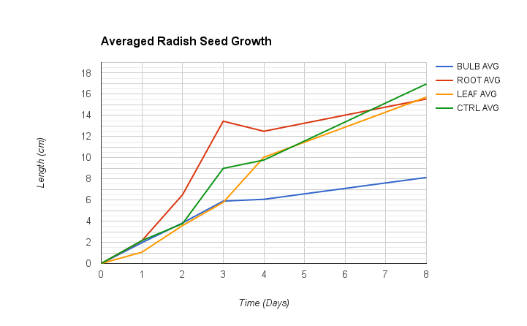

RESULTS:
In this experiment, the water soluble compounds from the radish leaves, roots, and the bulb were contained in separate bags. Compared with the control group, the compounds from the bulb groups reduced growth by 52.4%. The water soluble compounds from the leaves and roots were relatively close, with a percent difference of 1.9% and measurement difference of 0.3 centimeters.

ANALYSIS:
There was a significant detriment on the growth in length of the root of radish seeds when using parts of previous generations of radish in the soil.
The experiment started with the root and control group growing at a faster rate than the leaf and bulb group.Though it had begun that way, the leaf group grew at an average of 1.98 cm per day while the roots grew at 1.93cm per day. The control, growing at an average of 2.13 cm per day, ended as the tallest radishes with an average length of 17 cm. Taking percentages from the control compared to the root in terms of total growth length, we see that at the end of the 8 day period there was about a 52.4% difference in length between the two. To contrast this, the difference between the final growth lengths of the control and the root is 8.8% and difference between the control and the leaf is around 7.1%. There is clearly a major detriment in growth when exposed to the chemicals found within the bulb of the radish.
Amongst the liquids present in each respective bags, there was an interesting effect that occurred in the bulb and root bags. Due to the presence of whatever chemicals are in the root and bulb, the water changed colour from clear to a somewhat murky yellow. Therefore, the yellow compound does not affect growth. There was some notable loss in growth overall for the root, while the bulb took the largest hit based off of whatever may have been interfering within the radish bulb. There was also weakening of the roots in the bags with discoloured water, as when the paper began to be eaten through, some strands of root fibre were unable to retain strength. This led to several broken strands in the roots.
From observations, the control radishes were stronger, considering the fact that they were the only radishes that did not have troubles with toppling over. Some of the other radishes in the different variables were toppling over and many have fallen into the water, making them invalid to the data because they no longer stand.

CONCLUSION:
From the numerical data, there was a significant detriment on the growth in length of both root and hypocotyl of radish seeds when using parts of previous generations of radish in the soil. While there would be no major loss from the leaves, and only nominal loss from the roots, there would be a major problem that arises from the inclusion of the main body, or rather “bulb” section of radish. Due to some aspect of the biological chemistry, the radish seeds were left in an environment that was inhospitable, though not forbidding for their growth.

INSPIRATION:
This experiment has inspired more ideas, such as: trying to use different veggies, preferably those that grow as bulbs as well, in the same procedure to test if the bulb of another adult plant is really harmful for growing sprouts of the same species, or furthering the research into the chemicals compounds to figure it the chemical is just deterring the growth or if it’s actually poisonous to growing sprouts considering that the control group of the radishes did do better than all the changed variables.

CITATIONS:
http://0-www.learner.org.librus.hccs.edu/jnorth/tm/tulips/Allelopathy.html

http://www.units.miamioh.edu/dragonfly/itc/two.html

https://en.wikipedia.org/wiki/Volatilisation

